UE5.6

Static Mesh
Details:
- For many assets that previously used masked materials, such as fence meshes, please create solid models using Opaque materials instead because it has better performance and better look
- Foliage: mesh cards, masked material and LODs
- Walls should be no thinner than 10 centimeters (cm) to avoid light leaking.

Export Settings:
- Delete History
- Freeze Transformations
Enable: Smoothing Groups
Enable: Smooth Mesh
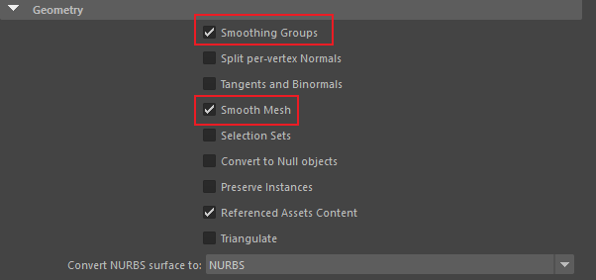

Import Settings:
Build Nanite: enabled
Auto Generate Collision: unknown, now enabled
Generate Lightmap UV's: disabled
Combine Meshes: depends on the exported mesh
Import Materials: disabled
Import Textures: disabled
Recompute Normals: disabled
Recompute Tangents: enabled
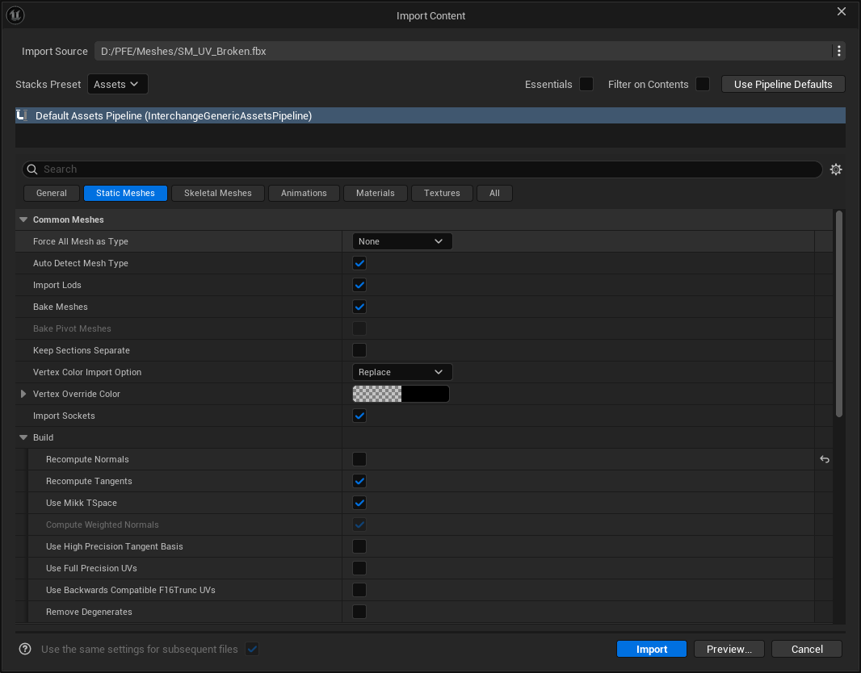

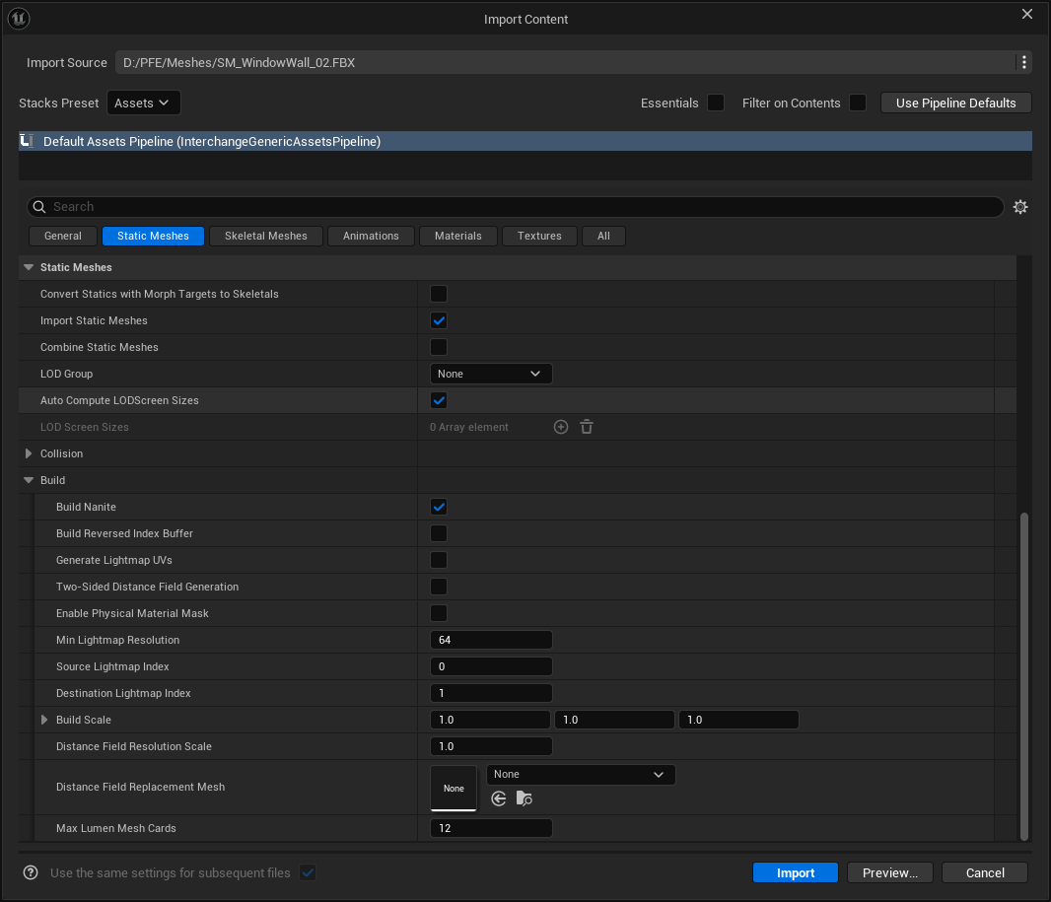

Materials
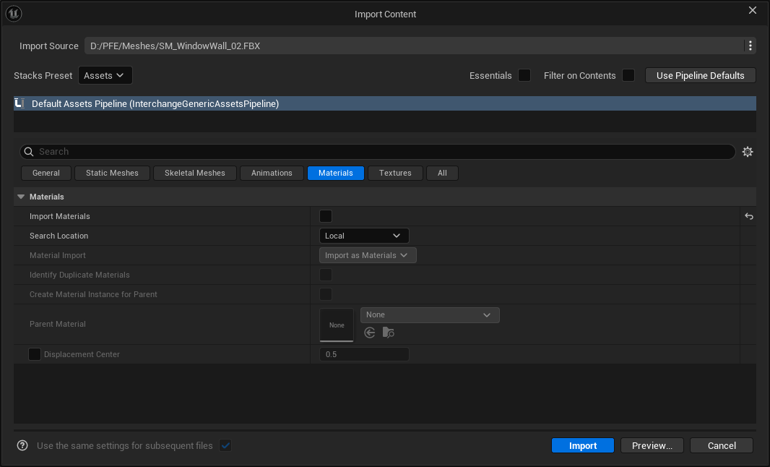

Textures
